**BrightBytes**

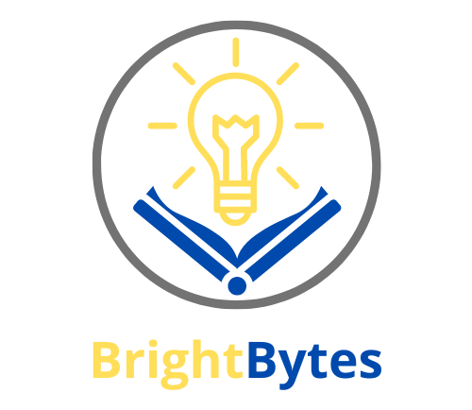

**TABLE OF CONTENTS**

1. **_About_the_team**
2. **_OUR_APP**
3. **_STAGES_OF_REALIZATION**
4. **_USED_TECHNOLOGIES**
5. **_APP_SCHEME**

# **About the team**

|  |  |  |
| --- | --- | --- |
| **Name** | **Class** | **Role** |
| **Виктор Кънев** | **9A** | **SCRUM TRAINER** |
| **Михаил Николов** | **9A** | **Back-end Developer** |
| **Недялко Либчев** | **9A** | **Back-end Developer** |
| **Теодор Маджаров** | **10A** | **Back-end Developer** |
| **Стелиян Николов** | **10Г** | **Back-end Developer** |
| **Кристиян Иванов** | **10Г** | **Back-end Developer** |
| **Полина Динева** | **10Г** | **QA** |

# **OUR APP**

**The idea of this app is to empower students on their educational journey. An app that not only teaches you but also tests your knowledge, ensuring you grasp every concept with confidence. Say goodbye to traditional textbooks and hello to a smarter, more engaging way to study.**

# **STAGES OF REALIZATION**



# **USED TECHNOLOGIES**

* **Visual Studio – for writing the code**
* **Power Point – for creating the presentation**
* **Word – for creating the documentation**
* **Git Hub – for project organization**
* **Git – to commit our changes**
* **C++ - for creating our app**
* **Canva – for creating the LOGO**

# **APP SCHEME**